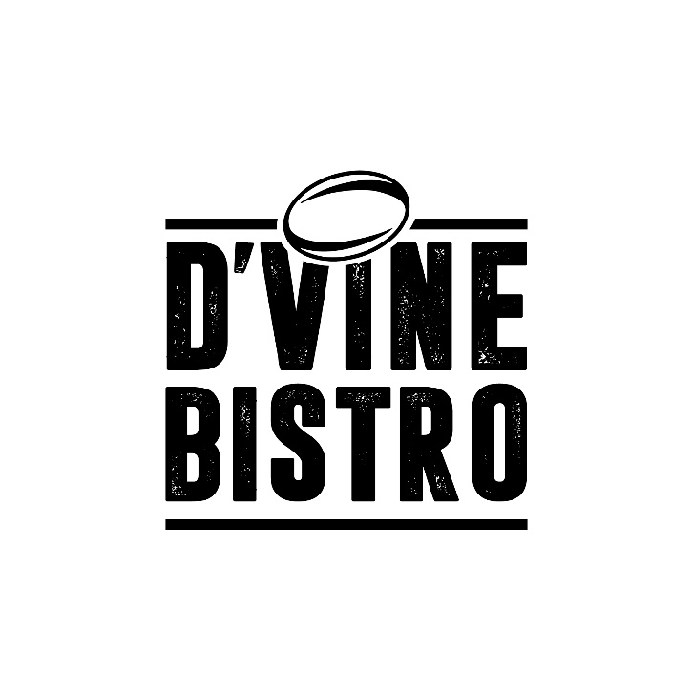

Breakfast
D’Vine Breakfast R48
(2 Eggs, 3 slices of Bacon, Tomato, Toast)
Starters
Deep Fried Mushrooms R48
Jalapeno Poppers R50
Salads
Deconstructed Caesar Salad R80
(Crispy Bacon, Chicken breast, Green Salad, Cheese slices, Pita)
Burgers (*Mondays R60)
D’Vine Burger (Served with Chips/Salad) R78
(Beef/Chicken, Salad Greens)
Saucy Burger R88
(Cheese/Pepper/Mushroom)
Cheesy Cheese Burger R90
(D’Vine Burger with a Cheese Slice and Cheese sauce)
Bacon & Egg Burger R90
(D’Vine Buger with Bacon & Egg on top)
Sandwiches (Served with Chips/Salad/Grilled veg)
Bacon and Cheese R60
Chicken and Mayo R65
Main Meals
Special Nachos – (*Fridays R60)
Nachos Plain R70
Nachos Bacon/Chicken/Beef R80
Bobotie R80
Chicken Strips and Chips R60
Bolognaise Pasta R75
Large plate of Chips R38
Grills (Served with Chips and Grilled Veg/Salad)
(*Wednesdays R100)
D’Vine Steak R145
Saucy Steak R160
(D’Vine Rump with choice of sauce Cheese/Mushroom/Pepper)
Directors Steak R170
(D’Vine Rump with whole Mushrooms smothered with Cheese & Garlic)
Desserts
Waffle and Ice Cream R48
Dom Pedro R45
(Whiskey/Amarula/Kahlua)
Kiddies Menu
Chicken Strips and Chips R45
Burger and Chips R40
Bacon & Cheese Sandwich R40
Small Plate of Chips R25
Drinks
Milkshakes (Lime, Banana, Chocolate, Strawberry, Vanilla) R30
Oros Juice R15
Soft Drinks (340ml / 200ml) R20/R15
Apple- and Grapetizer R25
Still / Sparkling Water R15
Score Energy Drink R25
Coffee / Tea / Americano R20
Cappuccino / Café Latte R25
Hot Chocolate R28

